Paul Rée (1849–1901)
Philosopher • Writer • Physician • Friend and Influence on Friedrich Nietzsche
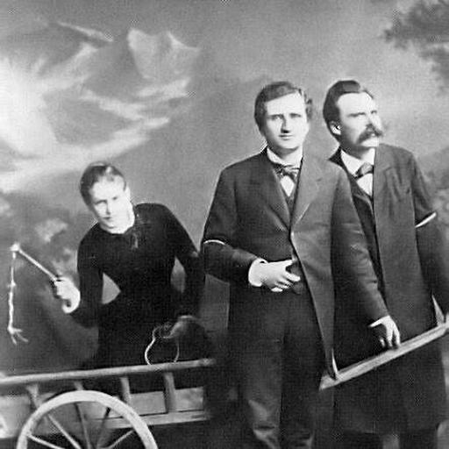  1882 photograph: Lou Salomé, Paul Rée, and Friedrich Nietzsche. Rée is the center figure.
  Quick Identification  • Full name: Paul Ludwig Carl Heinrich Rée.  • Dates: November 21, 1849 – October 28, 1901.  • Background: German philosopher, writer, later physician. | Best Known For  • Friendship with Nietzsche.  • Influence on Nietzsche’s middle-period turn toward psychology, skepticism, and the critique of morality.

1. Birth and Family Background
• Rée was born in Bartelshagen, in the Province of Pomerania, then part of Prussia.
• He came from a prosperous family; his father was a landowner/businessman.
2. Education
• Rée attended the Gymnasium in Schwerin.
• In 1869, he began studying philosophy and law at the University of Leipzig.
• After brief military service during the Franco-Prussian War, he also attended lectures in Berlin.
• In 1875, he qualified for his doctorate from the University of Halle with a dissertation on “the noble” in Aristotle’s ethics.
3. What Paul Rée Thought
Rée treated morality not as something handed down from God or discovered by pure reason, but as something that could be explained historically, psychologically, and biologically.
• Influenced by Darwin, Schopenhauer, French moralists such as La Rochefoucauld and La Bruyère, and empirical psychology.
• Rejected metaphysical and religious explanations of good and evil, traditional free will, and absolute moral responsibility.
• Important works: Psychological Observations and The Origin of the Moral Sensations.
4. What He Did for Nietzsche
Paul Rée helped push Nietzsche toward the style and subject matter we see in Human, All Too Human:
• from metaphysics toward psychology
• from Wagnerian romanticism toward skeptical analysis
• from grand systems toward aphorisms and observations
• from moral preaching toward diagnosis of motives
• from free will toward causal explanation
Rée’s influence is important because Nietzsche began to ask not simply, “Is this belief true?” but “What human need produced this belief?”
5. Rée and Nietzsche at Sorrento
• In 1876–1877, Nietzsche, Rée, and others spent time in Sorrento, Italy, under Malwida von Meysenbug’s patronage and friendship.
• This was crucial for Nietzsche’s break with Wagner and his turn toward the “free spirit.”
• Rée wrote much of The Origin of the Moral Sensations in Sorrento in autumn 1877.
6. The Friendship Later Collapsed
• Rée and Nietzsche were later both involved with Lou Andreas-Salomé.
• The famous 1882 triangular relationship among Nietzsche, Rée, and Lou Salomé became emotionally painful and helped end the friendship.
• Their friendship disintegrated in 1882.
7. Age Comparison in 1875
• Paul Rée: born Nov. 21, 1849; age 25 / 26 after Nov. 21.
• Nietzsche: born Oct. 15, 1844; age 30 / 31 after Oct. 15.
Why Paul Rée Matters for Chapter 7
Paul Rée represents the kind of thinker Nietzsche was becoming interested in during the Human, All Too Human period: skeptical, scientific, psychological, anti-metaphysical, suspicious of free will, and interested in the origins of morality.
Rée was not the cause of Nietzsche’s transformation by himself, but he was an important companion and catalyst during Nietzsche’s move away from Wagner, Schopenhauer, and metaphysical consolation.
Book-club takeaway: Rée helped make Nietzsche’s middle-period thinking more psychological, more skeptical, and more interested in the human origins of morality.

Paul Rée’s Birthplace Region
