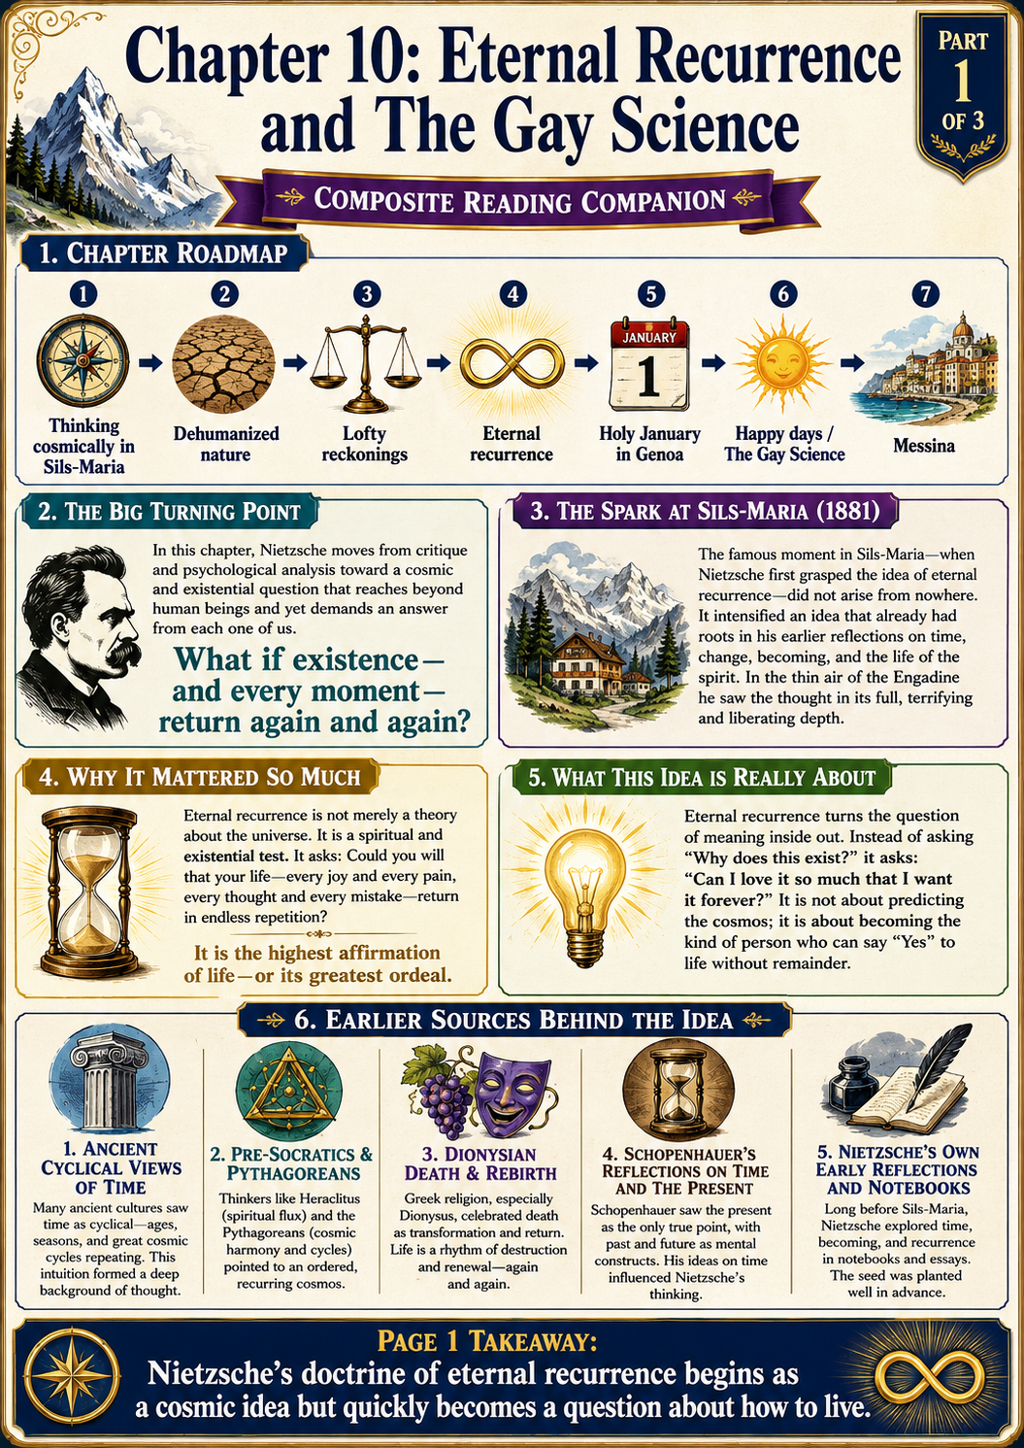
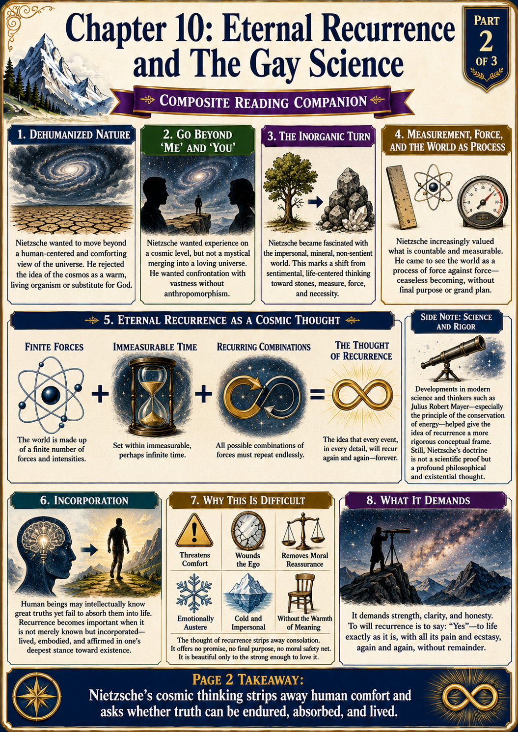
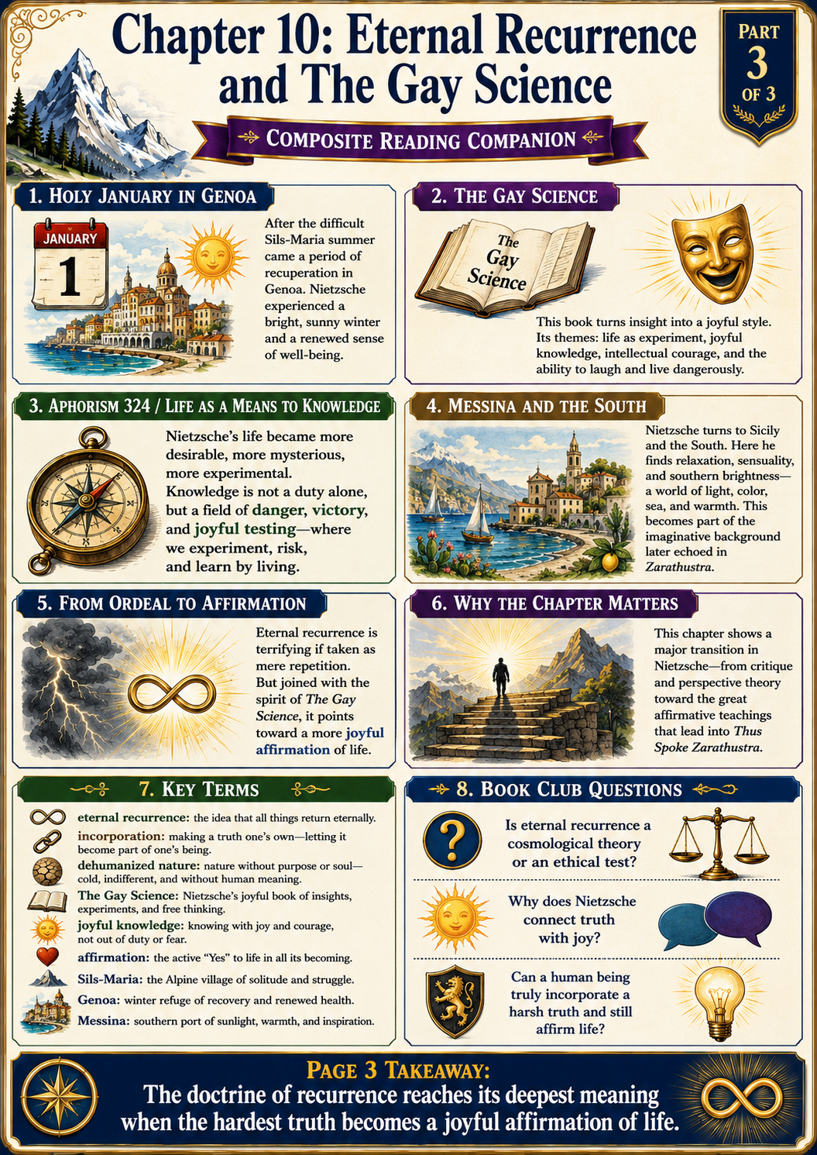
READING COMPANION GUIDE
Safranski on Nietzsche — Chapter 10
Eternal Recurrence and The Gay Science
TIME | PLACES | CENTRAL IDEA | EMOTIONAL RHYTHM
1881–1882 | Sils-Maria • Genoa • Messina | The recurrence of the same | Ecstasy joined to suffering

1. Older sources | 2. Cosmic thinking | 3. Dehumanized nature | 4. Eternal recurrence | 5. Joyful knowledge
Based on the photographed selections from Chapter 10, pages 223–244.

1. Central Meaning of the Chapter
• This chapter presents one of the decisive turning points in Nietzsche’s life: the summer of 1881, when the idea of eternal recurrence became emotionally and philosophically overwhelming for him.
• The idea was not entirely new. What was new was its force. An old theory of cyclical time suddenly became a personal revelation that Nietzsche believed could transform how a human being lives.
• Safranski connects three movements: stripping nature of human meaning, constructing a cosmic theory of repetition, and discovering a new kind of joyful, experimental philosophy in The Gay Science.
THE CHAPTER’S BIG QUESTION
• Can a person affirm life so completely that he would willingly live every detail again—forever?
• Can joy survive after God, purpose, and metaphysical consolation have been removed from the universe?
2. The Idea Was Both Ancient and Personal
• Cyclical time already appeared in Indic traditions, among the pre-Socratics and Pythagoreans, and in the Dionysian myth of a god who dies and is reborn.
• Nietzsche had encountered these ideas as a schoolboy. His 1862 essay “Fate and History” compared time to a cosmic clock whose movement begins again after completing its cycle.
• The Birth of Tragedy also spoke of an eternal core of existence beneath the continual destruction of individual forms.
• Safranski therefore suggests that Nietzsche did not simply invent eternal recurrence in 1881. He “re-originated” it: familiar materials suddenly became a life-changing insight.
3. Schopenhauer and the Image of “Eternal Noon”
• Schopenhauer imagined time as an endlessly revolving sphere while the present remains an indestructible “Now.”
• Safranski explains this with a geometric image: the present is like a fixed tangent touching the moving circle of time at one point.
• Human beings are part of the turning wheel because we live in time; yet in awareness and attention we also experience the persistent present.
• Nietzsche later carried the images of noon, eternity, and the great noon into Thus Spoke Zarathustra.
4. “Go Beyond Me and You”: Thinking Cosmically
• Nietzsche became dissatisfied with ordinary perspectivism. He wanted to escape the “fantastic ego” and experience existence on a cosmic level.
• This did not mean adopting a polite consensus or looking through many human eyes. He wanted to move beyond the entire human-centered framework.
• He also rejected the comforting picture of the universe as a living organism, a divine whole, or a cosmic womb. Such images merely smuggle God back into nature.
IMPORTANT DISTINCTION
• Cosmic thinking is not mystical union with a universal soul.
• It is an effort to encounter the universe without projecting human purpose, morality, personality, or comfort onto it.
5. Dehumanized Nature
• Nietzsche tried to imagine nature as radically inorganic: cold, impersonal, purposeless, and without a privileged place for sentient life.
• The stone becomes a symbol of this perspective. The organic world is temporary and exceptional; the inorganic realm is more basic and enduring.
• He suspected that feelings distort reality. Counting, measuring, and attending to material processes seemed to offer a way to reduce human projection.
• Even thought and emotion were increasingly interpreted as symptoms of bodily and physiological processes rather than activities of an independent spirit.
• His declared task was the “dehumanization of nature” and, in turn, the naturalization of humanity.
6. From Conservation of Energy to Recurrence
• In 1881 Nietzsche read the natural scientist Julius Robert Mayer, whose work helped establish the principle of conservation of energy.
• Mayer argued that energy changes form but does not disappear: heat may become motion, and material processes may be converted into one another while the total remains constant.
• Nietzsche supplied the further step. If the universe contains a finite quantity of force and a limited number of possible arrangements, but time is infinite, then every possible arrangement must recur.
• Mayer himself did not derive eternal recurrence from conservation of energy. The recurrence argument was Nietzsche’s speculative extension.
NIETZSCHE’S PROPOSED COSMIC ARGUMENT
• The quantity of force is finite.
• The number of possible combinations is limited.
• Time has no final endpoint.
• Therefore every configuration—including this exact life—must return repeatedly.
7. Eternal Recurrence in Plain Language
• Eternal recurrence is not simply the belief that history resembles itself or that similar events happen again.
• It means the recurrence of the same: each event, relationship, pain, pleasure, mistake, and decision returns in precisely the same form.
• It is not ordinary reincarnation. There is no separate soul moving into a new body; rather, the entire configuration of the world returns.
• There is no final goal, judgment, rescue, or permanent escape. The world does not progress toward a concluding state.
8. The Existential Test
• The real importance of recurrence is not the physics but the test it imposes on a life.
• How would you react if told that every moment must be lived again endlessly? Would the thought crush you, or could you welcome it?
• The doctrine measures the depth of one’s affirmation. To will the recurrence of one’s life is to accept not only its joys but also its losses, humiliations, errors, and suffering.
• This anticipates Nietzsche’s later ideal of affirming fate rather than seeking compensation in another world.
BOOK-CLUB THOUGHT EXPERIMENT
• Choose one ordinary day of your life—not your best day. Would you consent to repeat it eternally?
• What would need to change in the way you live today for your answer to become “yes”?
9. Sils-Maria: Ecstasy Joined to Illness
• Nietzsche associated his great inspiration with Sils-Maria in the Swiss Alps, near the boulder at Surlej.
• The insight brought elation and “tears of joy,” but the same summer also brought severe headaches, nausea, stomach cramps, cold, and despair.
• Safranski emphasizes the double condition: philosophical rapture did not remove bodily torment. Nietzsche’s highest exhilaration and his physical misery occurred together.
• Climate mattered greatly to him. He increasingly treated clear skies, dryness, warmth, and bodily well-being as conditions for thought itself.
10. Genoa and the “Holy January”
• After the difficult summer, Nietzsche spent the winter of 1881–1882 in Genoa and experienced an unusually mild, bright, and restorative season.
• He called January 1882 the most beautiful January of his life and named the fourth book of The Gay Science “Sanctus Januarius”—the holy January.
• The first four books of The Gay Science grew out of this recovered energy and incorporated the insights of the previous summer.
• The title points to a cheerful, free-spirited art of inquiry. “Gay” here means joyful, lively, and light-hearted—not a reference to sexual orientation.
• Nietzsche describes life as an experiment for the seeker of knowledge: dangerous, uncertain, but capable of being lived boldly and joyfully.
11. Consciousness, Error, and “Incorporation”
• Nietzsche regarded consciousness as a late and still-developing human capacity, not as the secure ruler of the organism.
• Consciousness frequently goes astray because older instincts developed long before reflective thought and continue to regulate life.
• “Incorporation” means more than understanding an idea intellectually. Knowledge must enter the body, instincts, emotions, habits, and culture until it changes the way life is actually experienced.
• We may intellectually accept that Earth moves around the sun and that humanity is cosmically temporary, yet emotionally we still behave as though the world revolves around us.
• Safranski’s striking formulation is that modern people may be Copernicans in theory while remaining Ptolemaists in their lived sense of importance.
12. New Truths and the Struggle for Life
• New knowledge creates a vortex: it disrupts familiar truths and inherited habits.
• At first, a new insight may be dismissed as madness because it challenges the conditions under which a culture has learned to survive.
• A truth becomes historically powerful only when people can incorporate it—when it acquires enough strength to reorganize life.
• This creates a paradox. Knowledge grows from instincts and life, yet a truth claim cannot be valid merely because it expresses an instinct.
• Nietzsche therefore enters a “house of mirrors”: every explanation of truth seems to reflect back upon the instincts and perspectives of the person making it.
13. Prophet, Clown, and Self-Mockery
• Nietzsche sensed that eternal recurrence was too extreme for ordinary philosophical presentation.
• The doctrine seemed suited to a prophet because it demanded conversion, but also to a clown because it could appear absurd, theatrical, or impossible to prove.
• Safranski portrays Nietzsche moving between solemnity and laughter, metaphysical intensity and self-mockery.
• The Gay Science does not eliminate the abyss beneath knowledge. It teaches a style of dancing, experimenting, and laughing while remaining aware of that abyss.
14. Messina, the South, and Carmen
• In spring 1882 Nietzsche unexpectedly sailed from Genoa to Messina, Sicily, traveling alone on a freighter.
• The journey south represented warmth, sensuality, gaiety, and liberation from the heaviness he associated with northern culture and Wagnerian solemnity.
• Hearing Bizet’s Carmen in Genoa helped intensify this fantasy of the Mediterranean south: rhythm, passion, fatalism, color, and bodily vitality.
• Nietzsche was delighted by Messina for several weeks, but the sirocco eventually drove him to Rome.
• In Rome he met Lou Salomé, opening the next dramatic and painful chapter of his life.
15. Major Contrasts to Watch
◆ Human-centered meaning versus Dehumanized nature
◆ Knowledge in the head versus Knowledge incorporated into life
◆ Organic universe versus Inorganic and mechanical universe
◆ Metaphysical consolation versus No refuge outside this world
◆ Physical agony versus Intellectual ecstasy
◆ Prophetic seriousness versus Laughter and self-mockery
◆ Northern heaviness versus Mediterranean gaiety
16. Key Terms
◆ Eternal recurrence: The hypothesis that the exact total sequence of events returns endlessly.
◆ Recurrence of the same: Not mere similarity, but the repetition of every detail in the same configuration.
◆ Dehumanized nature: Nature understood without moral purpose, divine design, or human-centered meaning.
◆ Perspectivism: The view that knowing always occurs from a standpoint; Chapter 10 shows Nietzsche testing the limits of this idea.
◆ Incorporation: The process by which knowledge becomes embodied in instinct, emotion, habit, and culture.
◆ The Gay Science: A joyful, experimental, self-questioning pursuit of knowledge that combines seriousness with artistic lightness.
◆ Eternal noon: The image of a permanent present within the turning circle of time.
17. Compact Timeline
1862 In “Fate and History,” the young Nietzsche already imagines cyclical cosmic time.
1872 The Birth of Tragedy links changing phenomena to an enduring core of existence.
Early summer 1881 Notebook entries attack the ego and call for experience on a cosmic level.
Summer 1881 At Sils-Maria, eternal recurrence becomes Nietzsche’s “main idea.”
Late summer–autumn 1881 Elation alternates with severe illness and despair.
Winter 1881–1882 A mild season in Genoa restores him.
January 1882 The “holy January” inspires the fourth book of The Gay Science.
Early 1882 Nietzsche completes the first four books of The Gay Science.
Spring 1882 He travels to Messina, then to Rome, where he meets Lou Salomé.
18. Questions for Book-Club Discussion
1. Is eternal recurrence mainly a scientific claim, a religious myth, or an ethical test? What changes depending on which interpretation we choose?
2. Why does Nietzsche believe that nature must be “dehumanized”? What comfort does he think human beings falsely project onto the universe?
3. Does a universe without purpose necessarily produce despair? How does The Gay Science attempt to produce joy instead?
4. Can knowledge truly be “incorporated”? What truths do we accept intellectually but fail to live emotionally?
5. Is Nietzsche’s argument from finite force and infinite time convincing? Does its philosophical value depend on its scientific truth?
6. Why are physical health, climate, landscape, and travel so important to his thinking? Should philosophy be understood partly as a bodily activity?
7. What is gained by combining the roles of prophet and clown? Can laughter make a terrifying idea more livable without trivializing it?
8. What does your reaction to eternal recurrence reveal? Does it expose regret, gratitude, fear, or a desire to live differently?
19. Bottom Line
CHAPTER 10 IN ONE PARAGRAPH
• Nietzsche attempts to face a universe stripped of God, purpose, and human privilege. From older ideas of cyclical time, Schopenhauer’s eternal present, and nineteenth-century theories of conserved energy, he fashions eternal recurrence: the possibility that every detail of existence returns forever. The doctrine becomes an extreme test of life-affirmation. His answer is not solemn resignation but The Gay Science—a philosophy that seeks knowledge experimentally, bodily, courageously, and with laughter, even while standing over an abyss.

