BEING MORTAL • PHILOSOPHER PROFILE
RONALD DWORKIN
Philosopher of Rights, Dignity, and Personal Autonomy
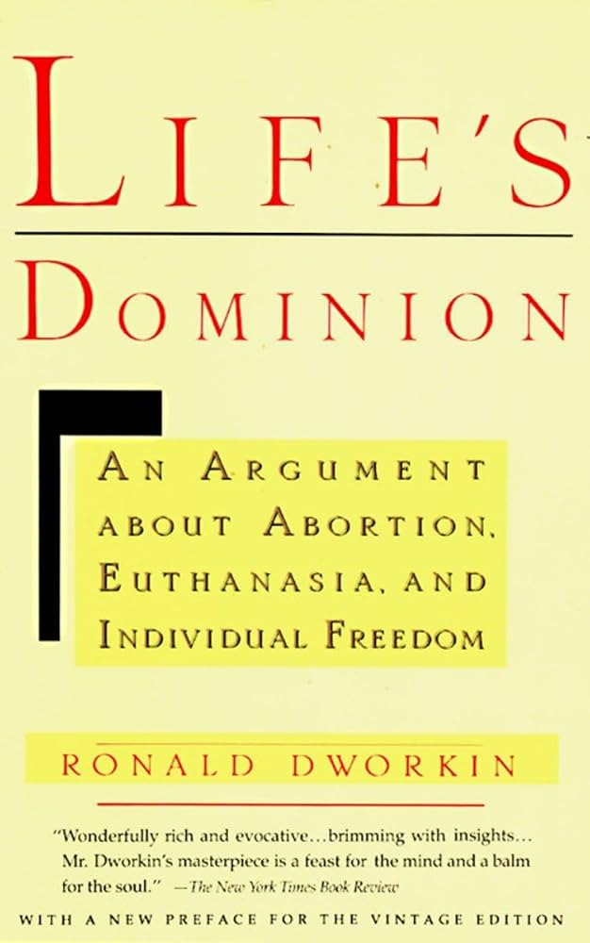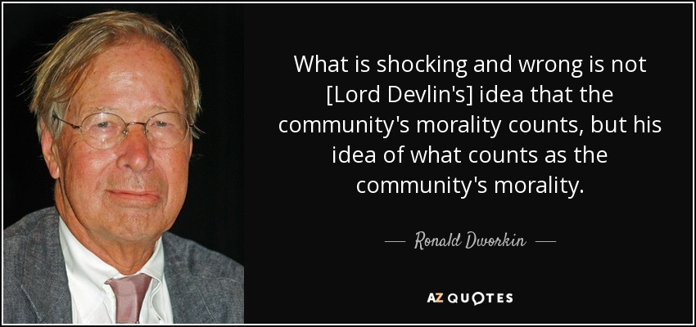
Life’s Dominion (1993) • Ronald Dworkin, legal and political philosopher

IN ONE SENTENCE: Dworkin argued that every human life deserves equal concern and respect, and that autonomy matters because it allows a person’s choices to reflect the values and identity that make the life recognizably his or her own.

Why He Appears in Being Mortal
Atul Gawande turns to Ronald Dworkin in Chapters 5–6 because Dworkin gives philosophical depth to a central question: What does it mean to care well for a person whose body, memory, or independence is declining? Dworkin’s answer begins with dignity and self-direction, not merely safety or medical control.
- A person may need extensive assistance and still retain meaningful autonomy.
- Good care should preserve identity, relationships, purpose, and control over decisions that matter.
- Longer life is not the only goal; the life being prolonged should remain connected to the person’s values.

Life and Education
- Born: December 11, 1931, in Worcester, Massachusetts; raised largely in Providence, Rhode Island.
- Education: Harvard College, Oxford University as a Rhodes Scholar, and Harvard Law School, where he graduated in 1957.
- Early legal training: Clerked for Judge Learned Hand of the U.S. Court of Appeals and then practiced at Sullivan & Cromwell in New York.
- Died: February 14, 2013, in London, after leukemia. He was 81.

An Exceptional Academic Career
Dworkin moved from legal practice to teaching and became one of the most influential legal philosophers of the twentieth century, working across law, ethics, political philosophy, and constitutional interpretation.
- Yale Law School: Taught law and held the Wesley N. Hohfeld Chair of Jurisprudence.
- University of Oxford: Succeeded H. L. A. Hart as Professor of Jurisprudence and became a Fellow of University College.
- New York University: Served as professor of law and philosophy and helped establish a renowned colloquium in legal, political, and social philosophy.
- University College London: Later held senior appointments in jurisprudence.

The Central Ideas

Equal Concern and Respect
Dworkin believed that a legitimate government must treat each person with equal concern and respect. Individuals are not merely cases, diagnoses, costs, or members of a statistical group. Each person’s life has importance from the inside—from the standpoint of the person living it.

Rights as Protections
He became famous for arguing that fundamental rights should operate as strong protections against majority preference or institutional convenience. A nursing home, hospital, court, or government cannot justify every intrusion simply by claiming that it serves efficiency, order, or the greatest overall benefit.

Law as Integrity
Dworkin rejected the idea that law is only a collection of enacted rules. Judges, he argued, must interpret statutes, precedents, and constitutional principles as parts of a coherent moral structure that fits legal history and presents it in its most principled light.

Autonomy as Authorship
For Dworkin, autonomy is deeper than being offered a menu of choices. It is the ability to shape one’s life in a way that expresses character, convictions, loyalties, and long-term purposes. This is why autonomy remains important even when age or illness makes complete independence impossible.
PLAIN-LANGUAGE DISTINCTION: Independence means doing everything without help. Autonomy means retaining meaningful authority over the life one is living. A person can lose independence yet still preserve autonomy.

Autonomy, Aging, and Dementia
Dworkin’s writing became especially important in debates about dementia, advance directives, euthanasia, and decisions near the end of life. He distinguished between two kinds of interests:
- Experiential interests: Present-moment experiences such as comfort, pleasure, pain, enjoyment, or distress.
- Critical interests: The commitments and values that give a whole life meaning—family, faith, work, dignity, achievement, responsibility, and the way a person wishes the life story to unfold.
The distinction becomes difficult when a person with dementia appears comfortable in the present but previously recorded different wishes for future medical care. Dworkin generally gave substantial moral weight to the person’s earlier, competent decisions because they reflected the values by which that person had chosen to organize an entire life.
That position remains debated because earlier instructions may undervalue the present person’s pleasures and attachments. Dworkin did not eliminate the dilemma; he made medicine and families take identity and life history seriously.

Life’s Dominion
Published in 1993, Life’s Dominion addresses abortion, euthanasia, individual freedom, and the moral significance people attach to human life. Its end-of-life arguments are the most direct bridge between Dworkin’s philosophy and Being Mortal.
- Human dignity includes respect for a person’s considered view of how life should be lived and concluded.
- Advance decisions can express a person’s values before illness removes the ability to speak or decide.
- End-of-life disagreements often involve not only pain and survival, but competing understandings of what gives a life integrity.

What Gawande Draws from Dworkin
Gawande uses Dworkin to challenge a system that makes safety the supreme value. Institutions may prevent falls and extend survival while unintentionally stripping away privacy, familiar routines, and meaningful choice.
- Ask what the person is willing to endure—and for what purpose.
- Identify the activities and relationships that make life worth living for that particular person.
- Treat medical care as a means of supporting a valued life, not as an end in itself.
- Balance protection with freedom, recognizing that a life without any risk may also be a life without sufficient meaning.
BOOK-CLUB CONNECTION: Dworkin helps explain why Gawande’s reformers focus on pets, plants, children, privacy, schedules, food choices, and ordinary responsibilities. These details are not luxuries; they help residents remain authors of their own lives.

Major Books
- Taking Rights Seriously (1977): Individual rights and his critique of legal positivism.
- Law’s Empire (1986): Law as interpretation guided by integrity.
- Life’s Dominion (1993): Freedom, dignity, abortion, euthanasia, and end-of-life decisions.
- Freedom’s Law (1996): A moral reading of the U.S. Constitution.
- Sovereign Virtue (2000): Equality and the fair distribution of resources.
- Justice for Hedgehogs (2011): A unified account of ethics, law, and justice.

Honors and Legacy
- Elected to the British Academy and the American Academy of Arts and Sciences.
- Received the Holberg International Memorial Prize in 2007 and the Balzan Prize for Jurisprudence in 2012.
- Remembered as a major public intellectual whose scholarship shaped debates about rights, equality, constitutional law, democracy, dignity, and medical ethics.

Five Points to Remember
- Dworkin was a philosopher of law, rights, equality, dignity, and personal responsibility.
- He understood autonomy as authorship of one’s life, not simply independence from assistance.
- He distinguished present experiences from the deeper interests that give an entire life meaning and coherence.
- His work supports Gawande’s argument that safety and longevity must serve the person’s purposes—not replace them.
- His approach makes end-of-life care a question about identity and values as well as medicine.

Selected Sources
- NYU Law — Ronald Dworkin memorial
- Georgetown Law — Life’s Dominion lecture
- Stanford Encyclopedia — Advance Directives
- Balzan Prize — Dworkin biography

