Keren Brown Wilson
The Birth of Assisted Living
A biography and Chapter 4 supplement to Atul Gawande's Being Mortal
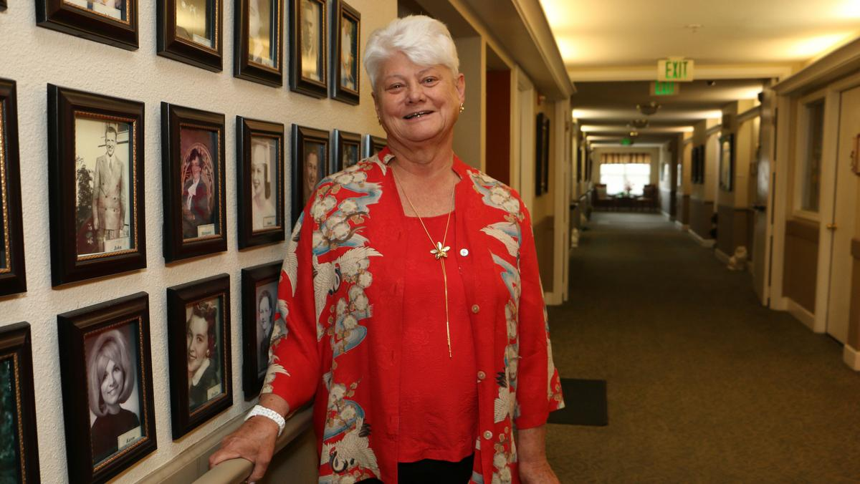
Left: Portland Business Journal / Cathy Cheney (2018). Right: West Virginia Public Broadcasting (2015). Used here for educational commentary.
CENTRAL IDEA Wilson did not merely redesign a nursing home. She proposed a different purpose for long-term care: provide needed help while allowing a person to remain the author of his or her own life.

Who Was Keren Brown Wilson?
Keren Brown Wilson is an American gerontologist, entrepreneur, educator, and advocate whose work helped establish the modern assisted-living movement. She grew up in War, West Virginia, and brought to elder care a perspective shaped by poverty, family illness, and the conviction that people with limited means deserved choices, too.
- Field and education: Gerontologist; Ph.D., Portland State University, 1983.
- Legacy: Professor, developer, and advocate frequently called the “mother of assisted living.”

The Experience That Changed Her Life
When Wilson was nineteen, her mother, Jessie F. Richardson, suffered a disabling stroke at fifty-five. Because Jessie was poor and relied on Medicaid, she spent much of her remaining decade in nursing homes. The institutions provided food, medicine, and supervision, but also controlled when residents rose, ate, bathed, slept, and received visitors. Dependence became a loss of authority over her own life.
THE CHALLENGE FROM JESSIE When Wilson spoke of a career in gerontology, her mother asked, “Why aren’t you doing something to help people like me?”

From a Family Problem to a Public Idea
Wilson reversed the usual question. Instead of asking how an institution could manage residents efficiently, she asked what help a person needed to retain preferences, privacy, relationships, and acceptable risks.
- Housing should feel like home, not a hospital ward.
- Assistance should not become total control.
- Safety should support a life worth living—not replace it.

The First Practical Test: Park Place
Wilson and her husband, gerontologist Michael DeShane, struggled for support because Medicaid generally paid for nursing homes, not flexible services in ordinary housing. They borrowed heavily and pressed ahead. In 1983, Park Place opened in Portland, Oregon, demonstrating the “Oregon model”: private apartments plus personal and nursing assistance.

What Park Place Changed
- Private space: apartments rather than institutional beds or wards.
- Control: residents could lock the door, arrange belongings, and direct the day.
- Flexible help: assistance with medicines, bathing, meals, and other needs.
- Negotiated risk: safety without surrendering all freedom.
- Affordability: inclusion of people with limited incomes.
THE BREAKTHROUGH Park Place separated dependence from helplessness. A resident could need substantial assistance and still exercise agency.

A Short Tick-Tock of Wilson’s Work
1983 | Park Place opens. Private apartments and individualized help demonstrate the Oregon model.

1988 | Company formed. Concepts in Community Living, Inc. is incorporated to develop and manage residences.

1994 | National expansion. Assisted Living Concepts, Inc. is organized as a corporate spinoff.

2001 | A new mission. The Jessie F. Richardson Foundation extends Wilson’s concern for underserved elders.

Names That Are Easy to Confuse
- Park Place (1983): Wilson’s pioneering Portland residence.
- Concepts in Community Living, Inc. (1988): Wilson and DeShane’s original operating and advisory company.
- Assisted Living Concepts, Inc. (1994): a corporate spinoff for national expansion.
- Jessie F. Richardson Foundation (2001): Wilson’s nonprofit for vulnerable elders.
THE SHORT ANSWER The company most directly associated with Wilson’s original assisted-living work was Concepts in Community Living, Inc.

What “Assisted Living” Originally Meant
Wilson joined three elements older systems separated: a real home, services that increased as needs changed, and consumer choice. The governing values mattered more than the architecture.
- Home: a private, recognizable place under the resident’s control.
- Help: reliable support with the activities of daily living.
- Agency: the resident continues to make consequential decisions.
- Dignity: bodily dependence does not erase adulthood.
- Purpose: daily life should still contain relationships, pleasures, and reasons to get up.

The Model’s Success—and Its Dilution
Assisted living spread rapidly, attracting capital and achieving scale. But the phrase also became a marketing label for facilities that did not preserve the original commitment to autonomy. Wilson later described explosive growth, Wall Street money, diluted ideals, and rising quality concerns. The name alone does not prove that a facility follows her philosophy.

How Wilson’s Story Fits Being Mortal
Chapter 4, “Assistance,” follows Gawande’s movement from independence to frailty and dependence. Wilson provides the constructive answer: dependence need not mean institutional surrender.
- Chapter 2: the body becomes less reliable.
- Chapter 3: nursing-home dependence can sacrifice privacy and choice.
- Chapter 4: assistance can preserve authorship of daily life.
GAWANDE’S GOVERNING CONTRAST Traditional institutions organize life around safety, efficiency, and liability. Wilson’s model asks how safety can serve what matters to the resident.

Why Agency Matters
Agency is not complete independence. A person may need help dressing, taking medicine, or moving safely and still choose when to wake, what to eat, whom to see, and which risks are worthwhile. Wilson designed care around that distinction. Her model also complements Maslow: care may provide food, shelter, and safety while neglecting belonging, esteem, identity, and purpose.

A Practical Test for Any Facility
The label “assisted living” is not enough. These questions test whether Wilson’s values are present:
- Who controls the daily schedule—and can residents choose their own routines?
- Is the apartment private, and are ordinary risks negotiated instead of automatically forbidden?
- Does the care plan begin with what matters to the person?
- Does the resident still have relationships, pleasures, roles, and purpose?

Wilson’s Later Work and Legacy
After leaving corporate assisted living, Wilson returned to people with the fewest resources. Through the Jessie F. Richardson Foundation, she supported community-based elder care in the United States and Nicaragua. Her 2007 history records the movement’s idealism, expansion, and danger of losing its founding values.

A Balanced Assessment
- Achievement: substantial care in a residential setting need not erase autonomy.
- Social insight: poor people deserved dignity and choice, not merely a cheaper institutional bed.
- Unresolved problem: commercialization sometimes preserved the label while weakening the philosophy.
- Continuing lesson: judge care by the life it permits, not only the harms it prevents.

CONCLUSION Wilson transformed her mother’s loss of choice into a model showing that assistance can protect freedom instead of extinguishing it.

Book Club Discussion Questions
- Is some loss of safety an acceptable price for preserving autonomy? Who should decide?
- Does “assisted living” describe a building, a set of services, or a moral philosophy?

Selected Sources
Gawande, Being Mortal, Chapter 4: “Assistance.” • Portland Business Journal profile (2018). • West Virginia Public Broadcasting profile (2015). • Wilson, “Historical Evolution of Assisted Living” (2007).

Three Things to Remember
1 ORIGIN  Jessie’s nursing-home experience turned a family injustice into Wilson’s life work. | 2 MODEL  Park Place combined private homes, flexible assistance, choice, and negotiated risk. | 3 STANDARD  Judge care by the agency and meaningful life it permits—not safety alone.

