BEING MORTAL • PHILOSOPHER PROFILE
JOSIAH ROYCE
Loyalty, Community, and the Search for a Meaningful Life
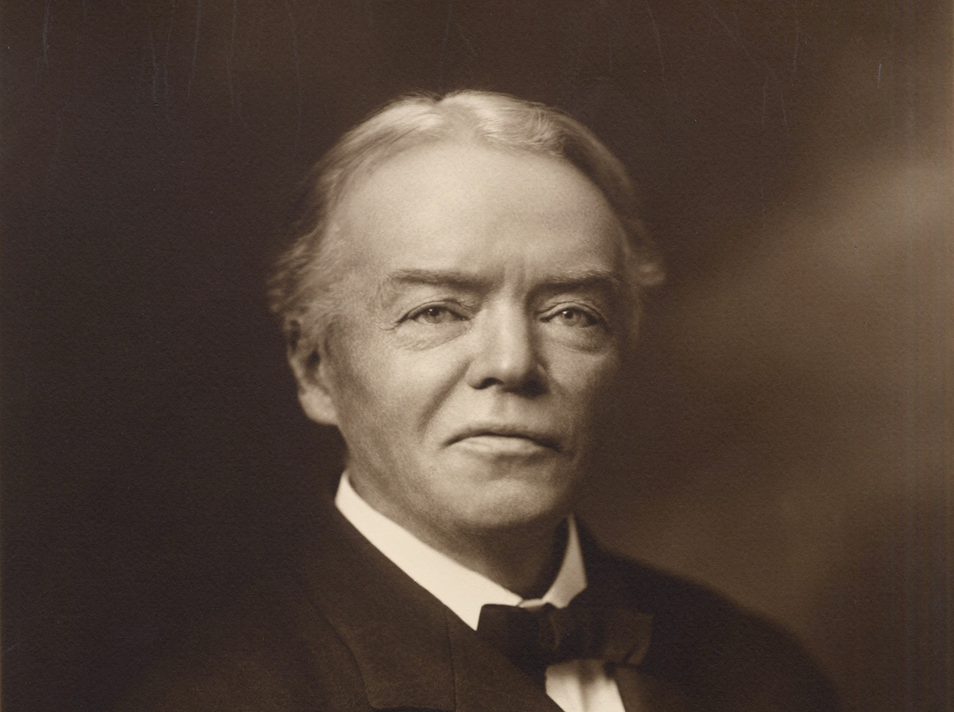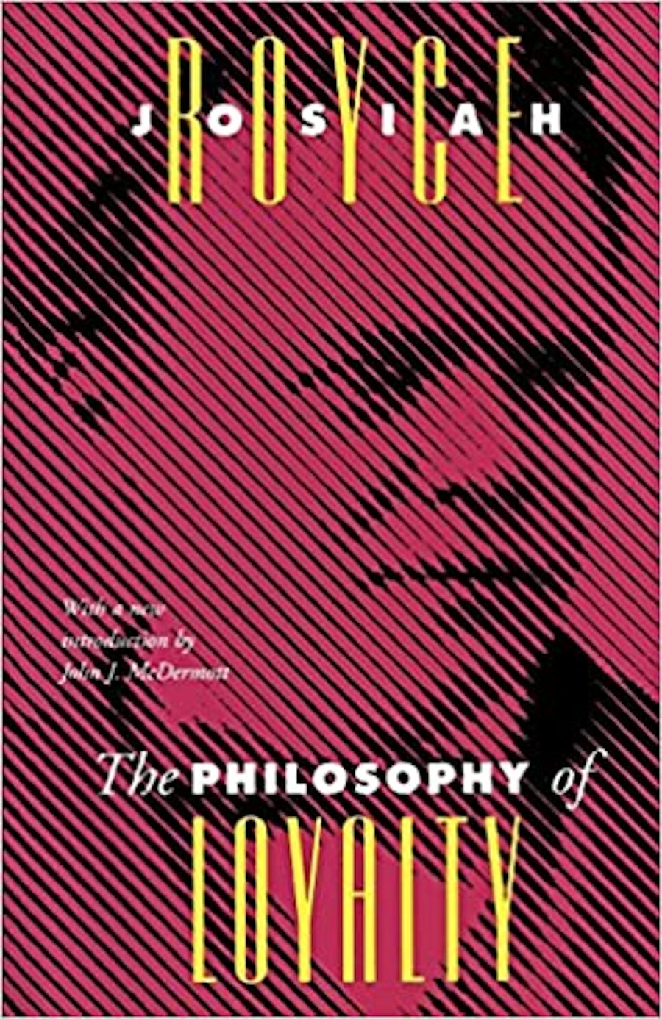
Josiah Royce (1855–1916) • The Philosophy of Loyalty, first published in 1908

IN ONE SENTENCE: Royce believed that life gains coherence and meaning when a person freely commits to a worthy cause shared with others—and remains loyal to it through practical service.

Why He Appears in Being Mortal
Atul Gawande turns to Josiah Royce in Chapter 6 while asking why mere safety and survival can leave people feeling empty. Royce supplies a philosophical answer: human beings need purposes that organize their lives and connect them to people and causes beyond themselves.
- Comfort can reduce suffering, but comfort alone does not create purpose.
- A meaningful responsibility can matter more than a perfectly protected routine.
- Old age and dependence need not erase meaning if the person can still love, contribute, choose, and serve.

Life and Education
- Born: November 20, 1855, in Grass Valley, California, a Gold Rush mining community.
- Family influence: His mother, Sarah Eleanor Bayliss Royce, was a teacher and community builder whose example helped shape his interest in social bonds and shared purposes.
- University of California: Entered the new university as a teenager and earned a B.A. in classics in 1875.
- Study in Germany: Spent a year learning German and attending philosophy lectures in Heidelberg, Leipzig, and Göttingen, including lectures associated with Hermann Lotze.
- Johns Hopkins University: Earned a Ph.D. in philosophy in 1878, among the first four doctorates awarded by the new university.
- Died: September 14, 1916, in Cambridge, Massachusetts, at age 60.

From California to Harvard
Royce returned to the University of California in 1878 to teach composition, literature, and rhetoric. In 1882 William James helped bring him to Harvard as a temporary replacement. The appointment became permanent, and Royce remained there for the rest of his career.
- He became Professor of the History of Philosophy in 1892 and later held Harvard’s Alford chair.
- James was both a close friend and philosophical opponent; their arguments sharpened each man’s ideas about truth, experience, and religion.
- His students included W. E. B. Du Bois, T. S. Eliot, George Santayana, C. I. Lewis, and Norbert Wiener.

The Problem Royce Was Trying to Solve
Why can life feel empty even when a person’s physical needs are met? Royce thought that our private wishes arrive as a jumble of appetites, fears, ambitions, and momentary pleasures. Without a larger aim, these impulses do not automatically form a unified life.
A meaningful life therefore needs a plan connecting past effort, present action, and future hope. Royce believed such plans usually arise through social causes—families, professions, faiths, communities, and movements that need sustained human service.
PLAIN-LANGUAGE IDEA: We do not discover meaning by looking only inward. We find it by choosing something worthy to care about and by becoming responsible for its future.

The Philosophy of Loyalty
Royce defined loyalty as a person’s willing, practical, and sustained devotion to a cause. A cause is not merely a preference. It is a purpose shared with others that calls for continued action over time.
- Loyalty focuses the will: It gives scattered desires a direction.
- Loyalty forms identity: The answer to “Who am I?” becomes connected to what and whom the person faithfully serves.
- Loyalty creates community: The individual joins others who are committed to the same purpose.
- Loyalty extends life through time: A cause may begin before us and continue after us, placing our actions in a larger story.

Loyalty Is Not Blind Obedience
Royce knew that people can devote themselves to destructive causes. Fanaticism, hatred, conquest, and criminal organizations may inspire intense commitment, but they damage the ability of other people to pursue worthy purposes.
His higher test was loyalty to loyalty. A good cause should strengthen rather than destroy the capacity of others to pursue worthy purposes. True loyalty remains self-critical and respects loyalties beyond one’s own group.

The Beloved Community
Royce argued that persons become fully themselves through relationships, shared memories, and common purposes. His ideal was a beloved community: a community united by truthful interpretation, mutual loyalty, and concern for the good of all its members.
- Community does not erase individuality; it gives each person a distinctive contribution to make.
- Martin Luther King Jr. later made the phrase “Beloved Community” widely known within his own Christian vision of justice and nonviolence.
The Philosophy of Loyalty grew from lectures delivered in 1906–07 and was published in 1908. It argues that isolated self-interest is too narrow for a fulfilling life and that the highest loyalty encourages worthy loyalty in others.

Why Royce Matters in Being Mortal
Gawande uses Royce to expose a weakness in institutional care. A nursing home may provide medication, meals, cleanliness, and protection while removing the responsibilities and relationships that gave a resident a reason to get up each morning.
- Plants, pets, and visits from children can restore the feeling that another living being depends on the resident.
- Helping another resident can preserve usefulness and belonging.
- A book club, religious practice, family role, or personal project can connect present life to a larger purpose.
BOOK-CLUB CONNECTION: Dworkin helps explain why a person must remain an author of his or her own life. Royce helps explain what makes that life worth authoring: devotion to people and purposes beyond the isolated self.

Meaning Can Continue in Old Age
Royce’s philosophy does not require strength, employment, or complete independence. A person can remain loyal even when the form of service changes, provided the person can still participate in a valued relationship or cause.
- Guiding younger people and preserving family stories
- Participating in worship, community life, or a book club
- Caring for a plant, animal, neighbor, or fellow resident
- Completing a letter, memoir, artwork, or personal project

Major Books
- The Religious Aspect of Philosophy (1885): Early idealism, truth, error, and religion.
- The World and the Individual (1899–1901): His major metaphysical work, developed from the Gifford Lectures.
- The Philosophy of Loyalty (1908): Loyalty as the basis of a unified and morally meaningful life.
- The Problem of Christianity (1913): Interpretation, atonement, community, and religious life.

Honors and Distinctions
Royce won no famous competitive prize; his stature was recognized through elections, presidencies, honorary degrees, and prestigious lectureships.
- Elected Fellow of the American Academy of Arts and Sciences.
- Invited to deliver the Gifford Lectures at the University of Aberdeen in 1899 and 1900.
- President of the American Psychological Association (1902) and American Philosophical Association (1903).
- Elected to the National Academy of Sciences in 1906.
- Honorary degrees included Aberdeen (1900), Yale and Harvard (1911), and Oxford (1913).

Legacy
Royce helped establish American idealism while moving toward pragmatism. His work anticipated later discussions of identity, community, moral psychology, and care.
- UCLA’s Royce Hall and several schools, libraries, and landmarks bear his name.
- His ethics asks institutions not only how to protect life, but how to preserve purpose.

Five Points to Remember
- Royce was an American philosopher, historian, teacher, and major Harvard figure.
- Mere existence can feel empty because disconnected desires do not create a coherent life.
- Meaning grows through freely serving a worthy cause shared with others.
- Moral loyalty supports—not destroys—the worthy loyalties of other people.
- In Being Mortal, Royce explains why purpose, responsibility, and being needed are essential to humane care.

Selected Sources
- Stanford Encyclopedia — Josiah Royce
- National Academy of Sciences — Josiah Royce
- Vanderbilt University Press — The Philosophy of Loyalty

