BOOK CLUB READING ROOM | MEDICINE, ETHICS, AND AGING
BEING MORTAL
Chapters 1-4 and Tolstoy's Ivan Ilyich
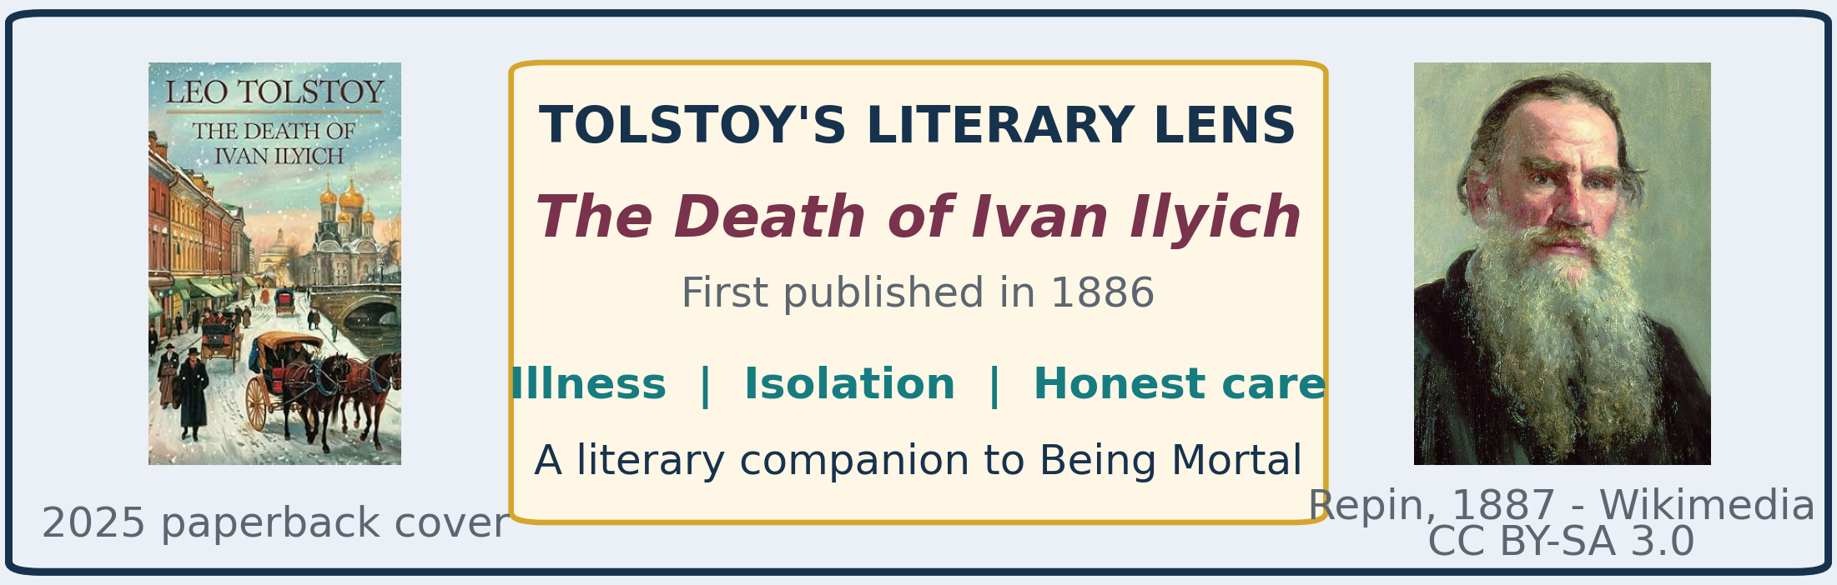
THE GOVERNING QUESTION
When health and independence decline, how can care preserve a life that still feels like one's own?
Reading status: through Chapter 4 | Companion plan: author biography + 8 chapters + epilogue

THE COMPANION FRAMEWORK
The book contains eight chapters plus an epilogue. With the separate Atul Gawande biography, the full reading companion is planned as ten resources.
- Author biography - Atul Gawande
- Chapter 1 - The Independent Self
- Chapter 2 - Things Fall Apart
- Chapter 3 - Dependence
- Chapter 4 - Assistance
- Chapter 5 - A Better Life
- Chapter 6 - Letting Go
- Chapter 7 - Hard Conversations
- Chapter 8 - Courage
- Epilogue
PROGRESS NOTE The completed author biography represents 1 of 10 planned resources, or 10%. The reader has now reached Chapter 4.

THE FIRST FOUR CHAPTERS: ONE ARGUMENT
Gawande builds a progression rather than presenting four separate topics. Each chapter moves the reader closer to the book's central moral problem: how to protect a person's agency when the body becomes less reliable.
THE PROGRESSION Independence -> gradual decline -> dependence -> assistance with autonomy
CHAPTER 1 | THE INDEPENDENT SELF
Gawande presents independence as the modern ideal of old age. He contrasts traditional family-supported aging, including his grandfather's life in India, with the American hope of remaining at home and making one's own decisions.
Central question: How long can independence be maintained, and what happens when it can no longer be maintained safely?
CHAPTER 2 | THINGS FALL APART
Aging usually unfolds gradually. Vision, hearing, balance, memory, muscle strength, and the ability to recover begin to deteriorate. A person may still feel mentally independent while becoming physically less capable.
Central question: When does living independently become too dangerous?
CHAPTER 3 | DEPENDENCE
Many older people eventually need help with bathing, dressing, eating, medications, or safe movement. Families may be overwhelmed, and the nursing home becomes the default. Safety and medical oversight increase, but privacy, choice, routine, and purpose may shrink.
Central question: Is keeping someone safe the same as helping that person live well?
CHAPTER 4 | ASSISTANCE
Assisted living was conceived as a more hopeful alternative: provide necessary help without taking over the person's life. Residents could keep private apartments and possessions, choose their schedules, lock their doors, and accept reasonable risks.
Central question: Can assistance preserve agency instead of replacing it?

WHAT AGENCY MEANS HERE
Agency is the ability to make meaningful choices about how one's own life is lived. It includes more than major medical decisions. It can involve when to wake, what to eat, whether to close a door, what risks to accept, and which relationships or activities give the day purpose.
- Nursing-home priorities often emphasize efficiency, schedules, safety, and legal protection.
- A resident's priorities may emphasize privacy, familiar routines, freedom, companionship, and reasons to keep living.
- The label 'assisted living' is not a guarantee. Some facilities gradually reproduce the controls of conventional nursing homes.
GAWANDE'S BETTER QUESTION Not merely, 'How can we keep this person safe?' but, 'How can we help this person continue living a life that still feels like their own?'

TOLSTOY'S LITERARY CONNECTION
Ivan Ilyich is the fictional central character in Leo Tolstoy's novella The Death of Ivan Ilyich, first published in 1886. His story illuminates a central argument of Being Mortal: serious illness is not merely a medical problem. It is also a human struggle involving dignity, honesty, companionship, and meaning.

Who Is Ivan Ilyich?
- A successful judge. Ivan is a respected nineteenth-century Russian judicial official.
- A socially proper life. He pursues advancement, status, financial security, an elegant home, and the appearance of family respectability.
- Not evil, but superficial. He avoids emotional intimacy and painful questions, retreating into work and society when his marriage becomes unhappy.
- Control shattered by illness. He believes he has arranged life correctly until pain and physical decline destroy the order on which his identity depends.
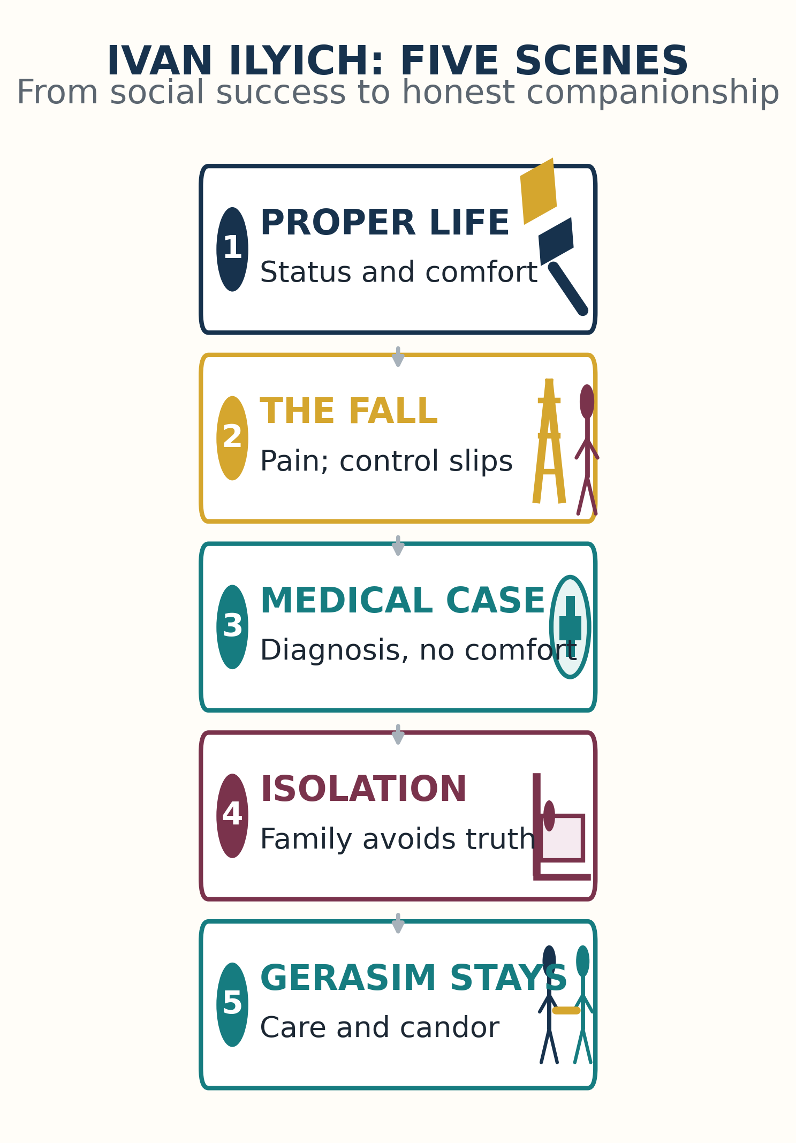
Story arc: social success gives way to illness, isolation, and finally honest human care.

THE TICK-TOCK OF IVAN'S DECLINE
- The successful official. Ivan advances through the judicial system and believes that he has arranged his life according to society's correct rules.
- The seemingly minor accident. While decorating a new home, he climbs a ladder to show how curtains should be hung, slips, and strikes his side against a window frame.
- The mysterious illness. Persistent pain and an unpleasant taste develop. Tolstoy does not identify the disease, which intensifies Ivan's uncertainty and fear.
- The failure of the doctors. Physicians debate diagnoses but do not address what Ivan most wants to know: Am I dying? Their detachment echoes Ivan's own formal behavior in court.
- Denial by family and friends. Nearly everyone maintains the pretense that recovery is likely. His wife resents the disruption; colleagues wonder who will inherit his position.
- The appearance of Gerasim. A young peasant servant enters the story with physical strength, emotional directness, and no fear of acknowledging death.
- Physical comfort. Ivan's pain eases when Gerasim supports his legs on his shoulders. Gerasim willingly performs intimate care and sometimes remains through the night.
- Emotional honesty. Gerasim calmly recognizes that Ivan is dying. His candor ends the exhausting pretense imposed by other people.
- Human companionship. Gerasim sees a suffering person rather than a patient, burden, official, or inconvenience. He offers presence, touch, compassion, and permission to speak honestly.
- The final realization. Ivan questions whether a life devoted to appearances and advancement was truly good. Compassion for his wife and son begins to replace self-absorption, and his terror recedes.

WHY GERASIM MATTERS
Gerasim cannot cure Ivan, but he makes Ivan's remaining life bearable. The household's lowest-status person understands the dying man more fully than the doctors, judges, relatives, and socially sophisticated visitors.
- Practical assistance - he tends to Ivan's bodily needs without embarrassment or resentment.
- Honest recognition - he acknowledges that Ivan is dying instead of forcing him to participate in false hope.
- Compassionate companionship - he remains present during suffering, even when nothing can be fixed.
- Preserved dignity - he does not treat dependence as humiliating or caregiving as beneath him.
THE IRONY The servant with the least social standing provides the most humanly intelligent care.

HOW TOLSTOY ILLUMINATES BEING MORTAL
- Ivan's doctors concentrate on disease while failing to understand what the experience of dying means to him.
- His family avoids honest conversation, leaving him emotionally isolated even when other people are physically nearby.
- His loss of independence makes him dependent on others for intimate bodily care.
- Gerasim shows that good care includes listening, candor, relief of suffering, touch, and steadfast presence.
- When medicine cannot restore health, the task changes: help the person live as well and meaningfully as possible for the time that remains.
THE SHARED LESSON Medicine treats the body; humane care recognizes the whole person and the need not to face mortality alone.

BOOK CLUB DISCUSSION STARTERS
- At what point does protection become control?
- Which ordinary choices are most important to preserving a person's sense of self?
- Why does honest acknowledgment of death comfort Ivan more than the optimism of his family and doctors?
- Does accepting reasonable risk sometimes produce a better life than maximizing safety?
- What qualities make Gerasim a better caregiver than people with greater education and status?
- How might a doctor, family member, or institution ask what matters most before deciding what care should look like?

THREE DISTINCTIONS TO CARRY FORWARD
- Safety versus agency - safety protects the body; agency protects the person's sense that life is still their own.
- Treatment versus care - diagnosis matters, but humane care must also listen, comfort, and remain present.
- False reassurance versus honest companionship - Gerasim cannot prevent Ivan's death, but he prevents Ivan from facing it entirely alone.

