ATUL GAWANDE  SURGEON • WRITER • PUBLIC-HEALTH INNOVATOR  Author of Being Mortal: Medicine and What Matters in the End | 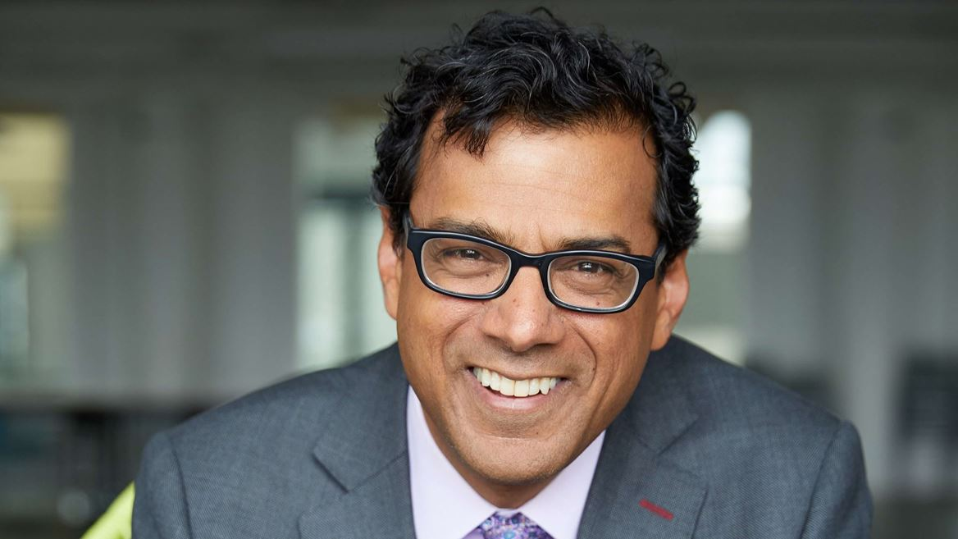

AT A GLANCE
• Born: November 5, 1965, Brooklyn, New York
• Raised: Athens, Ohio
• Fields: Surgery, public health, medical writing
• Known for: Being Mortal and the WHO Surgical Safety Checklist
• Military service: None found; his federal service was civilian
EARLY LIFE AND FAMILY
Atul Atmaram Gawande was born on November 5, 1965, in Brooklyn, New York, and raised in Athens, Ohio, where he and his sister, Meeta, attended local schools. He graduated from Athens High School in 1983. Growing up in an immigrant household in a small Midwestern university town helped shape his interest in medicine, public service, and the problems faced by ordinary patients.
His parents, Dr. Atmaram Gawande and Dr. Sushila Goswami Gawande, were physicians who had emigrated from India. His father became a urologist, and his mother practiced pediatrics. Their careers showed him medicine as both technical work and community service. His father’s later illness became central to Being Mortal.
EDUCATION
• Stanford University — Bachelor of Arts and Sciences, 1987, with studies in biology and political science.
• Balliol College, Oxford — Rhodes Scholar; master’s degree in philosophy, politics, and economics, 1989.
• Harvard Medical School — Doctor of Medicine, 1995.
• Harvard School of Public Health — Master of Public Health, 1999.
• Brigham and Women’s Hospital — completed general-surgery residency training in 2003.
MILITARY AND GOVERNMENT SERVICE
No reliable source indicates that Gawande served in the military. His government service was civilian: he advised Bill Clinton’s 1992 campaign and administration on health policy, and from January 2022 to January 2025 he led global-health programs at the U.S. Agency for International Development. He has reported on military medicine, but that writing was not military service.
SURGEON AND TEACHER
Gawande practiced general and endocrine surgery at Brigham and Women’s Hospital and held senior appointments at Harvard Medical School and the Harvard T.H. Chan School of Public Health. His research asks why complex medical systems fail and how teamwork, communication, measurement, and reliable routines can reduce preventable harm.
WRITER AND PUBLIC THINKER
A New Yorker staff writer since 1998, Gawande often begins with a patient, operation, or hospital problem and widens the story into an examination of uncertainty, cost, safety, judgment, and dignity. His clinical authority and clear storytelling make difficult medical questions accessible without making them simplistic.
BOOKS
• Complications: A Surgeon’s Notes on an Imperfect Science (2002) — explores uncertainty, error, and learning in surgery; it was a National Book Award finalist.
• Better: A Surgeon’s Notes on Performance (2007) — examines how professionals improve through diligence, ingenuity, and moral responsibility.
• The Checklist Manifesto: How to Get Things Right (2009) — argues that well-designed checklists can prevent avoidable failures in complex work.
• Being Mortal: Medicine and What Matters in the End (2014) — investigates aging, serious illness, autonomy, hospice, and the limits of medicine.
IMPROVING MEDICAL SYSTEMS
Gawande helped found Ariadne Labs and co-founded Lifebox, organizations that develop practical ways to improve health systems and surgical safety. His work with the World Health Organization contributed to the Surgical Safety Checklist, a short team procedure designed to prevent avoidable errors.
From 2018 to 2020, he was chief executive of Haven, the health-care venture created by Amazon, Berkshire Hathaway, and JPMorgan Chase. The appointment reflected his standing as a physician able to connect bedside realities with large-scale reform.
MAJOR AWARDS AND HONORS
• Rhodes Scholarship — supported his graduate study at Oxford.
• MacArthur Fellowship, 2006 — honored his creativity and influence as a surgeon and writer.
• Two National Magazine Awards — recognized excellence in his magazine journalism.
• AcademyHealth Impact Award — honored research with major influence on health-care practice and policy.
• Lewis Thomas Prize for Writing About Science — recognized his ability to unite scientific understanding and humane writing.
• Elected member of the National Academy of Medicine — one of the leading professional honors in American medicine.
• Honorary Doctor of Public Service from Ohio University — recognition from the community in which he was raised.
WHY BEING MORTAL BECAME PERSONAL
Being Mortal began with a professional problem: physicians are trained to fight disease but are often poorly prepared to help people live well when cure is no longer possible. The issue became personal when Gawande’s father developed a spinal-cord tumor and the family had to weigh treatment, disability, independence, pain, and additional time.
The experience reinforced his conclusion that medicine’s purpose is larger than survival. Good care begins by learning what the patient considers essential—home, mental clarity, relationships, or a treasured activity—and matching treatment to those priorities.
“The work of medicine is not merely to prolong life, but to help people preserve the reasons they wish to be alive.”
A concise statement of the argument developed in Being Mortal
BOOK-CLUB PERSPECTIVE
Gawande approaches mortality as a surgeon accustomed to intervention, a researcher concerned with systems, a son confronting his father’s decline, and a writer attentive to individual lives. Those roles make Being Mortal both analytical and intimate. He does not reject modern medicine; he asks it to be honest about its limits and responsive to the patient’s values.
His authority comes not only from credentials but also from his willingness to examine the failures of his profession and his own uncertainty as a son and physician. That combination of expertise and humility gives the book much of its moral force.
SELECTED SOURCES
Official biography: atulgawande.com. Additional biographical and award information: MacArthur Foundation; Ohio University; Rockefeller University; National Book Foundation; The New Yorker. Photograph: Library of Congress newsroom media asset.

