BOOK CLUB READING ROOM | BEING MORTAL SUPPLEMENT
ABRAHAM MASLOW
The Hierarchy of Needs as a Lens for Understanding Chapter 4
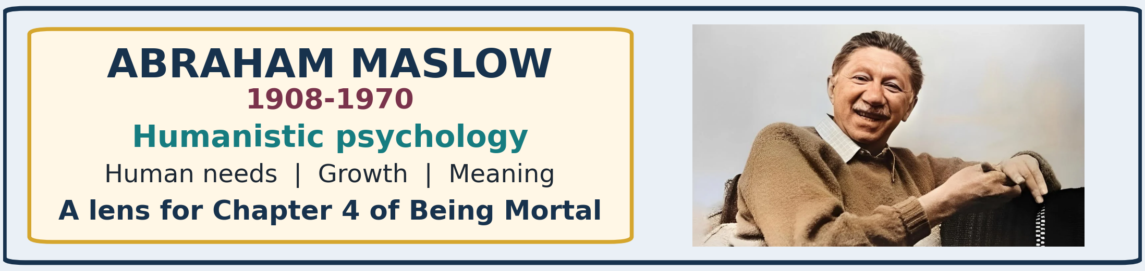
CENTRAL INSIGHT A care system can satisfy hunger, hygiene, medication, and physical safety while still depriving a person of belonging, dignity, choice, and purpose.

ABRAHAM MASLOW: LIFE AND WORK
Abraham Harold Maslow was an American psychologist whose work helped establish humanistic psychology. Instead of concentrating only on mental illness, conditioning, or unconscious conflict, he asked what enables people to become healthy, creative, purposeful, and fully human.
- 1908 - Brooklyn beginnings. Born April 1, 1908, Maslow was the eldest of seven children in a Jewish immigrant family. He later described his childhood as lonely and found refuge in books and study.
- Education and early research. After beginning college in New York and briefly attending Cornell, he studied psychology at the University of Wisconsin. Graduate work with Harry Harlow on primate behavior gave him rigorous scientific training before his later turn toward human motivation.
- Brooklyn College. From the late 1930s he taught at Brooklyn College. Ruth Benedict and Max Wertheimer helped shape his interest in unusually healthy, creative, and accomplished people.
- Brandeis University. In 1951 he joined Brandeis and chaired its psychology department for many years, becoming a leading voice in the humanistic movement.
- A third force. Humanistic psychology was presented as an alternative to both psychoanalysis and behaviorism. It emphasized freedom, responsibility, meaning, creativity, and the potential for growth.
- Major work and final years. His 1943 article introduced the hierarchy; Motivation and Personality (1954) and Toward a Psychology of Being (1962) expanded his ideas about growth, peak experiences, and self-actualization. He died June 8, 1970.

WHY HIS APPROACH WAS DIFFERENT
Maslow did not deny illness, conflict, or biological need. He argued that psychology was incomplete if it studied only what goes wrong. A full account of human life must also explain love, confidence, creativity, moral aspiration, fulfillment, and meaning.
- The person is more than a diagnosis or a collection of symptoms.
- Human beings continue to seek growth after immediate deficiencies are relieved.
- Health includes the ability to choose, relate, create, and pursue purposes that matter.
CONNECTION TO AGING Frailty may change what a person can do, but it does not erase the person's psychological needs or moral status.

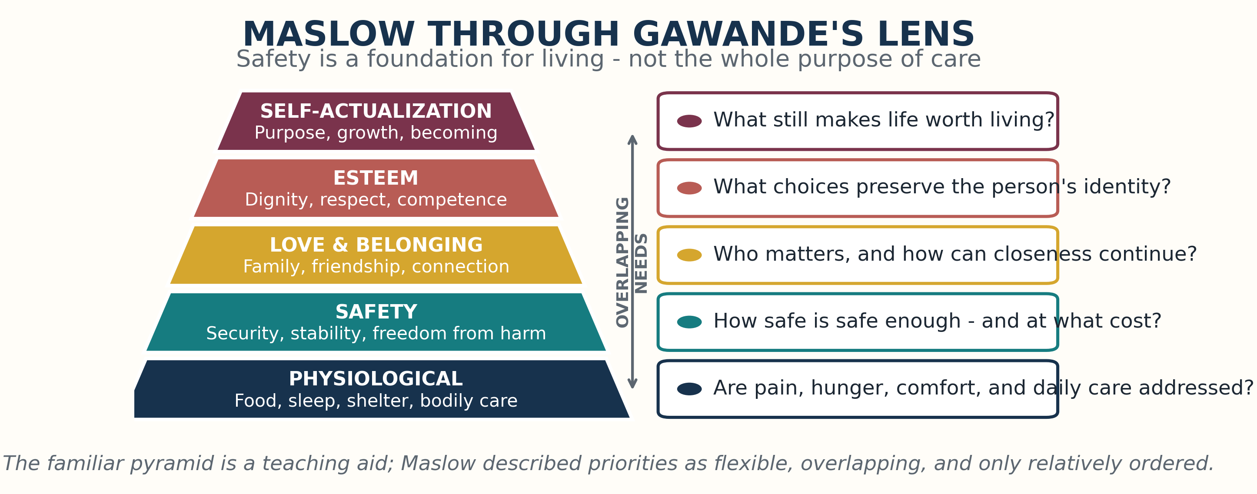

THE FIVE LEVELS IN PLAIN LANGUAGE
- Physiological needs - survival and bodily comfort. Food, water, air, sleep, shelter, warmth, elimination, relief of pain, and basic medical care.
- Safety needs - protection and stability. Freedom from danger, a predictable environment, adequate treatment, and confidence that help will be available.
- Love and belonging - human connection. Family, friendship, affection, community, being known, and the opportunity to give as well as receive care.
- Esteem - dignity and competence. Self-respect, privacy, recognition, useful roles, independence where possible, and freedom from being treated like a child.
- Self-actualization - purpose and growth. Using one's capacities, pursuing personally meaningful goals, expressing values, creating, learning, contributing, and becoming more fully oneself.

A NECESSARY CORRECTION: THE PYRAMID IS NOT A STAIRCASE
The famous pyramid is a later teaching device, not a diagram that Maslow published. Maslow described needs as a hierarchy of relative strength: when a basic need is seriously frustrated, it tends to dominate attention. He did not claim that one level must be completed perfectly before another can exist.
- Several needs can operate at the same time.
- People may pursue love, dignity, art, faith, or meaning even amid danger, illness, or poverty.
- Culture, personality, history, and circumstance can change the order and importance of needs.
- The hierarchy is best used as a checklist of human needs, not as a rigid law.
FOR BEING MORTAL The model is useful precisely because it asks what care may be overlooking - not because every resident must climb the same five steps.

CHAPTER 4: WHAT INSTITUTIONS USUALLY DO WELL
Traditional nursing homes were built largely around medical supervision, efficiency, and protection. These priorities are important, especially when residents are frail. In Maslow's terms, they concentrate strongly on the first two levels.
- Meals, bathing, medications, wound care, and emergency response support physiological needs.
- Fall prevention, monitoring, locked doors, standardized routines, and staff oversight support safety.
- Families may feel reassured that the resident is supervised and basic care is reliably delivered.
THE PROBLEM A system designed around what staff can schedule and measure may confuse protection with a complete account of well-being.

WHAT CAN BE LOST
- Belonging. Relocation may separate people from neighborhoods, friends, pets, familiar faces, and ordinary family life. Group activities cannot automatically replace relationships that matter.
- Esteem. Rules about waking, eating, bathing, doors, possessions, and movement may communicate that residents are no longer competent adults. Dependence can become infantilization.
- Self-actualization. When every risk is removed and every day is prearranged, there may be little room for purpose, contribution, privacy, challenge, or personal growth.

THE SAFETY PARADOX
Safety is indispensable, but maximizing safety can itself cause harm. A resident may be physically protected while becoming lonely, passive, bored, humiliated, or stripped of the ordinary decisions that make life recognizable as their own.
- Eliminating every risk can eliminate freedom.
- Preventing every possible fall can also prevent movement, spontaneity, and participation.
- Longer life is not automatically better life if the person loses all control over how the days are lived.
GAWANDE'S MORAL SHIFT The goal of care is not merely survival under supervision. It is the best life still possible under conditions of dependence.

WHY ASSISTED LIVING WAS MORE HOPEFUL
In Chapter 4, Gawande presents the original assisted-living idea associated with Keren Brown Wilson as an effort to provide help without taking possession of a person's life. Care would be available, but the resident would remain the central decision-maker.
- A private apartment rather than an institutional room
- A door the resident could close and lock
- Personal possessions and familiar surroundings
- Choice about waking, eating, bathing, and daily routines
- Help offered in the background instead of control imposed in the foreground
- Acceptance of reasonable risk when that risk protects a valued way of living
AGENCY Assistance should enlarge what a frail person can still choose and do; it should not automatically replace the person's judgment with the institution's convenience.

MASLOW'S FIVE-LEVEL TEST FOR A CARE SETTING
- Body. Are pain, sleep, appetite, mobility, hygiene, and medical needs addressed in ways the person can tolerate?
- Safety. Which risks truly threaten the person, and which restrictions mainly protect the institution from uncertainty?
- Belonging. Who does the person need to see, touch, call, help, or live near in order not to feel socially erased?
- Esteem. What decisions, responsibilities, possessions, private spaces, and useful roles preserve adult identity?
- Purpose. What makes the person want to get up tomorrow - a project, faith, family role, garden, pet, conversation, music, or service?

EVERYDAY CHOICES CARRY HIGHER NEEDS
Maslow's levels are not abstract luxuries. They appear in ordinary decisions that institutions can either preserve or erase.
- Food is physiological - and also personal. Choice of menu, timing, culture, and companionship can protect identity and pleasure.
- A locked door is safety - and also esteem. It can protect privacy and signal that the resident still controls access to personal space.
- A visit is belonging - and also purpose. A grandparent may still teach, advise, comfort, or participate in family life.
- A modest risk can be self-actualizing. Walking outdoors or making one's own schedule may preserve meaning even when it cannot be made perfectly safe.

LIMITS OF THE FRAMEWORK
Maslow's model remains influential because it is memorable and humane, but it is not a clinical rule or a proven universal sequence.
- Research does not strongly support one fixed order for every person and culture.
- The theory grew from a largely Western, individual-centered view of fulfillment.
- People can display courage, love, creativity, spirituality, and sacrifice while lower needs remain unmet.
- A resident's own account of what matters should outrank any generic pyramid.

BOOK CLUB DISCUSSION QUESTIONS
- Does a nursing home have a moral obligation to support higher needs, or only to provide competent care and safety?
- Which forms of risk should an older adult be allowed to accept in order to preserve a valued life?
- Is privacy a safety issue, an esteem need, a basic right - or all three?
- What would you personally identify as the one activity, relationship, or freedom that makes life feel like your own?
- Does Gawande improve on Maslow by replacing a general hierarchy with the more personal question, 'What matters to you?'

WHAT TO REMEMBER
1 Maslow's great contribution was to insist that human beings need more than the removal of pain and danger.
2 Chapter 4 shows how an institution can succeed at bodily care and safety while failing at belonging, dignity, agency, and purpose.
3 Assisted living is most humane when assistance supports the resident's chosen life instead of substituting a standardized life.
4 The pyramid is a useful prompt, but the individual person's values remain the decisive guide.

SOURCES AND IMAGE CREDIT
- Atul Gawande, Being Mortal: Medicine and What Matters in the End (2014), Chapter 4, 'Assistance.'
- Abraham H. Maslow, 'A Theory of Human Motivation,' Psychological Review 50 (1943): 370-396.
- Abraham H. Maslow, Motivation and Personality (1954); PBS, 'People and Discoveries: Abraham Maslow.'
- Todd Bridgman, Stephen Cummings, and John Ballard, 'Who Built Maslow's Pyramid?' Academy of Management Learning & Education 18 (2019).
- Portrait: user-selected colorized Abraham Maslow image from Get Therapy Birmingham; underlying William Carter portrait is also available through Wikimedia Commons.
- Hierarchy graphic: original Book Club Reading Room visualization created for this document.

